
Why Tactical Portfolio Management?

A long-term perspective of the Dow Jones Industrial Average since 1896 reveals the reality that there are extended periods of time in which the US equity market will trend generally upwards, and also lengthy periods of time where the market will instead stagnate or move generally lower. There have been nine such alternating cycles since 1896, with each averaging 14 years in duration. Let's say an individual begins to accumulate meaningful wealth with which to invest around the age of 40, and has a life expectancy of about 85 years, he or she will likely experience three of these cycles during their investment lifespan. With this in mind, it is important to have at one's disposal strategies that are effective in both generally rising (bull) markets and falling (bear, or "fair") markets.
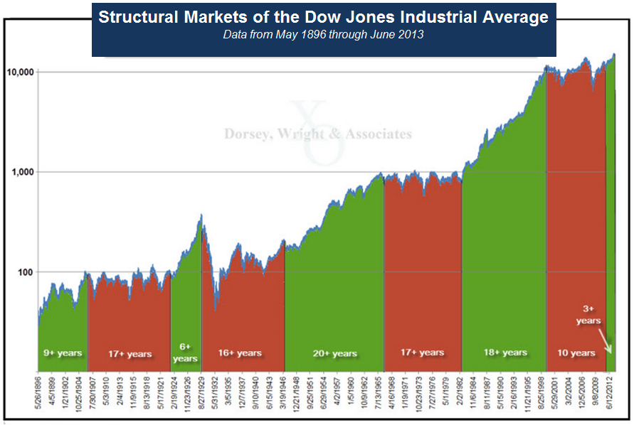

One methodology that has existed since the late-1800's and been proven effective in both kinds of markets is that of the Point & Figure methodology. The first proponent of the methodology was Charles Dow, also the original editor of the Wall Street Journal. Charles Dow was a fundamentalist at heart, yet he appreciated the merits of recording price action and understanding the supply and demand relationship in any investment. The Point & Figure methodology has developed over the past 100+ years, but remains at its core a logical, organized means for recording the supply and demand relationship in any investment vehicle. As both consumers and investors we are innately familiar with the forces of supply and demand; it is after all the first subject introduced in any ECONOMICS 101 class, and we experience its impact regularly in our daily lives. We know why tomatoes in the winter don’t often taste particularly good, don’t have as long a shelf life, and are paradoxically more expensive than those sent to market in July. What many investors are slow to accept is that the very same forces that cause price movement in the supermarket also trigger price movement in the financial markets. When all is said and done in a free market of any kind, if there are more buyers than sellers willing to sell, the price will move higher. If there are more sellers than buyers willing to buy, the price must move lower. If buying and selling are equal the price will remain the same. By charting this price action in an organized manner we hope to ascertain who is winning that battle, sellers or buyers, supply or demand. By having the ability to evaluate changes in the market we have taken the first step toward also becoming responsive to both bullish and bearish periods.

Broaden Your Investment Scope

Many investors equate investing to buying stocks. But over the last ten years the access to other asset classes traditionally only available to large institutional investors has become available to a much wider segment of the population. By broadening the places for investment from just US stocks to other asset classes like international stocks, commodities, currencies, fixed income and even cash alternatives gives you greater flexibility in your investments when US Equities are not in favor. As you can see from the graphic or “quilt” below, asset classes tend to rotate in and out of season just like the produce in the supermarket does. Over the last ten years, no one asset class has held the top spot for performance in each and every year. Sometimes US equities were at the top, sometime they were at the bottom. Sometime Commodities found their way to the top in terms of performance while in other years it was Fixed Income or Cash Alternatives. Just as a chef will seasonally adjust his menu offerings based upon the freshest produce available, investors should be willing to shift their portfolio focus based upon what asset class is in season.
US Stocks
International Stocks
Commodities
Foreign Currency
Fixed Income
Cash

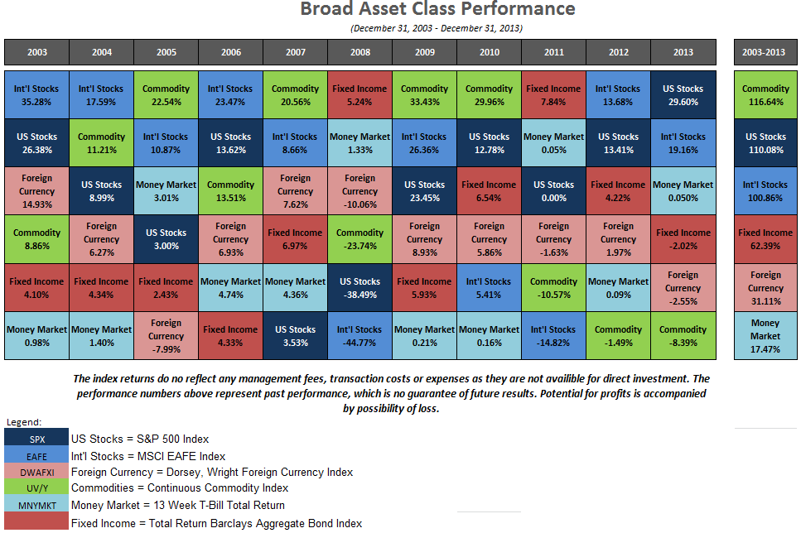
Tactical Portfolio Research

Tactical decisions are made utilizing the research and evaluation techniques of Dorsey, Wright & Associates who has extensive expertise in a technique known as Point & Figure charting. This type of analysis attempts to evaluate the supply and demand forces of particular asset classes and ranks the asset classes from strongest to weakest based upon relative strength (RS). We feel asset classes can be ranked similar to the way one might rank sports teams. If you think about your favorite sport, they rank teams based upon how well they perform against their opponents. The more games, matches or races won, the higher in ranking the team will go. We believe the same thing can be done in the investment markets. In the financial markets, a “game” is played each day and it consists of comparing the daily performance of one asset class to another. Each day we compare asset classes to one another to determine which asset classes are the strongest or weakest compared to one another. The ranking process is comprised of the following 4 steps and represents DWA's Tactical Portfolio Research strategy ("the strategy").
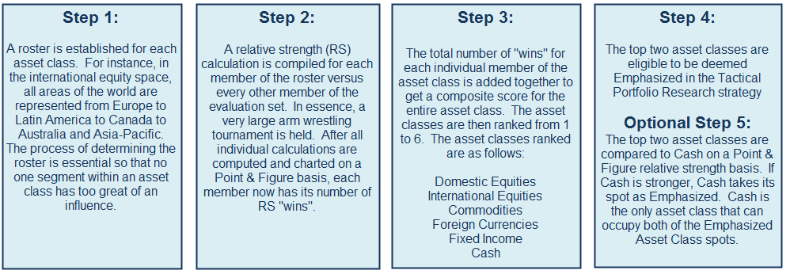

Each day, thousands of calculations are done to support the Tactical Portfolio Research and determine which asset classes have emerged as the leaders according to this methodology. As the asset classes fluctuate in strength, emphasized asset classes in the strategy will also change reflecting current market trends.



Asset Allocation is broadly defined as an investment strategy which assigns specific percentages of a portfolio to the different asset types discussed earlier. The portfolio is then periodically rebalanced to the target percentages. The theory behind asset allocation is that by spreading exposure across several asset classes, risk can be reduced in the overall portfolio. A tactical approach to asset allocation is grounded in the premise of similarly having exposure to multiple asset classes, but the tactical part of the strategy is to use a concept such as DWA’s Tactical Portfolio Research (TPR) to determine the weighting of each asset class, and that that weighting won’t stay exactly the same over time; it will fluctuate depending on trends in the market. Recall that TPR is designed to look at the following six asset classes and then determine which two should be emphasized based upon a relative strength ranking system. At any one time in the TPR strategy, two asset classes are overweighted, with Cash Alternatives being the only asset class that can occupy both of the top spots. The asset classes examined are as follows: Domestic Equities, International Equities, Commodities, Currencies, Fixed Income and Cash Alternatives.
Implementation: Tactical Asset Allocation
The foundation of DWA’s tactical asset allocation process is that four asset classes will always be represented in the Tactical Asset Allocation Portfolio (“portfolio”) with a 15 percent weighting each: Domestic Equities, International Equities, Commodities and Currencies. That equals 60 percent of the portfolio. The remaining 40 percent will be split between the two asset classes favored in TPR. So if equities are showing the strongest relative strength, then 35 percent will be in Domestic Equities (15 percent standard allocation and the additional 20 percent for TPR) and 35 percent will be in International Equities (15 percent standard allocation and the additional 20 percent from TPR). When equities are the weakest of the asset classes and Cash Alternatives is the strongest based upon TPR, the portfolio can hold 40 percent in cash alternatives and the equity allocation will be ratcheted down to 30 percent (15 percent standard allocation to domestic and international equities each). Dorsey, Wright & Associates feels the tactical asset allocation provides a systematic and disciplined way of overweighting asset classes when they are in favor on a relative strength basis, and it also provides a way of putting Cash Alternatives into the mix when there is no better place to be.
The relative strength strategy does not stop with just determining the strongest asset class. The next step is to use the relative strength methodology to determine which are the strongest areas within the emphasized asset class. There can be a significant benefit in skewing the portfolio toward those sectors performing the best provided you don’t jump in at the top. Of course you will not know where the top is since we do not have a crystal ball, which is why it’s important to have professional help. Sometimes the Domestic Equity space will be overweighted in energy and other times it might be Technology, and yet other times it might be Healthcare; and we believe the underlying methodology to determine this is the Dorsey, Wright relative strength ranking system of comparing sectors to each other to determine whose relative strength charts are positive.
Sometimes the Tactical Asset Allocation Portfolio will look like this:
And other times the Tactical Asset Allocation Portfolio will look like this:

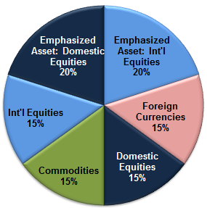
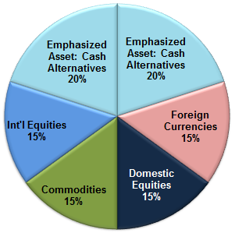

Charts are for illustrative purposes only, do not represent any actual portfolio or investment and are not a solicitation or an offer to buy any security instrument or to participate in any trading strategy.
Investment and insurance products:
NOT FDIC-Insured | NO Bank Guarantee | MAY Lose Value

The information contained herein has been prepared without regard to any particular investor’s investment objectives, financial situation, and needs. Accordingly, investors should not act on any recommendation (express or implied) or information in this material without obtaining specific advice from their financial advisors and should not rely on information herein as the primary basis for their investment decisions. Information contained herein is based on data obtained from recognized statistical services, issuer reports or communications, or other sources believed to be reliable (“information providers”). However, such information has not been verified by Dorsey, Wright & Associates, LLC (DWA) or the information provider and DWA and the information providers make no representations or warranties or take any responsibility as to the accuracy or completeness of any recommendation or information contained herein. DWA and the information provider accept no liability to the recipient whatsoever whether in contract, in tort, for negligence, or otherwise for any direct, indirect, consequential, or special loss of any kind arising out of the use of this document or its contents or of the recipient relying on any such recommendation or information (except insofar as any statutory liability cannot be excluded). Any statements nonfactual in nature constitute only current opinions, which are subject to change without notice. Neither the information nor any opinion expressed shall constitute an offer to sell or a solicitation or an offer to buy any securities, commodities or exchange traded products. This document does not purport to be complete description of the securities or commodities, markets or developments to which reference is made.

Keep in mind that there is no assurance that this or any strategy will ultimately be successful or profitable.

The relative strength strategy is NOT a guarantee. There may be times where all investments and strategies are unfavorable and depreciate in value. Relative Strength is a measure of price momentum based on historical price activity. Relative Strength is not predictive and there is no assurance that forecasts based on relative strength can be relied upon.

Past performance is not indicative of future results. Potential for profits is accompanied by possibility of loss. You should consider this strategy’s investment objectives, risks, charges and expenses before investing. The examples and information presented do not take into consideration commissions, tax implications, or other transaction costs.

Index definitions:
Continuous Commodity Index: A broad grouping of 17 different commodity futures, which is a benchmark of performance for commodities as an investment. The index was developed in 1957.
Total Return Barclays Aggregate Bond Index: a market capitalization-weighted index that includes Treasury securities, Government agency bonds, Mortgage-backed bonds, Corporate bonds, and a small amount of foreign bonds traded in U.S. The total return Index reflects the reinvestment of dividends.
Dorsey, Wright Foreign Currency Index: An equal weighted index comprised of eight foreign currencies. The index is rebalanced on a daily basis and measured by pricing all currencies against the US Dollar.
S&P 500 Index: S&P 500 index consists of 500 stocks chosen for market size, liquidity, and industry group representation. It is a market value weighted index with each stock’s weight in the Index proportionate to its market value
MSCI EAFE Index: Morgan Stanley Capital International Europe, Australasia and Far East {“MSCI EAFE”} Stock Index is an unmanaged group of securities widely regarded by investors to be representations of the stock markets of Europe, Australasia and the Far East. Source MSCI. MSCI makes no express or implied warranties or representations further redistributed or used as a basis for other indices or any securities or financial products. This article is not approved, reviewed or produced by MSCI.
Dow Jones Industrial Average (DJIA): The DJIA is an un-weighted index of 30 “blue-chip” industrial U.S. stocks.

